The ZGWA 5-DAY SUMMER SESSHIN
East Fremantle
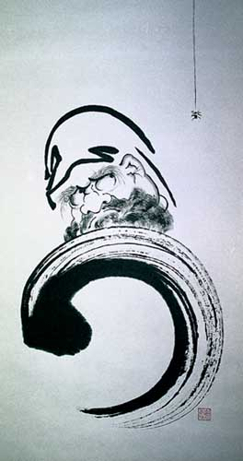
Friday 24 January – Tuesday 28 January 2020

Led by Ross Bolleter Roshi & Mari Rhydwen Roshi

To touch the Mind, to settle the Mind, to convey the Mind

Date/time: From mid-day set-up for an evening start on Friday 24 January to the afternoon of Tuesday 28 January 2020.

Venue: A Place to Just Be - 4A Preston Point Road, East Fremantle.

Part-time attendance may be possible. Please contact Sesshin Coordinator Andrea Donohue if you need to negotiate part-time attendance.

PAYMENT DETAILS |  | No  Days | Full Fee | Concession Fee* | Dana Offering
BSB 126-568, Account No. 4333 1663  - provide surname in ‘description’ | Member | 5 | $330 | $250 | $380
 | Non-M. | 5 | $370 | $290 | $420
 | Part time | 1 | $100 | $75 | $20 per day

SESSHIN COSTS

*Concession fees are available to people who have Health Care or Pension cards. If you are having difficulty paying, speak with the Sesshin Coordinator, Andrea Donohue (on Thursdays at St Paul’s, or (donohues@iinet.net.au; 0415 913 144).

WHAT YOU WILL NEED TO BRING:

- Please bring your own mat, cushion (zafu) and stool if you have one and indicate on your application form. Otherwise, we can provide them for you.
- A pillow and blanket for rest breaks.
- Plain dark-coloured clothing.
- A torch (essential).

REGISTRATION FORM
The ZGWA 5-Day Summer Sesshin
A Place to Just Be, Friday 24 January – Tuesday 28 January 2020

Name: ___________________________________________
Address: ______________________________________________________________
Phone: _____________________ E-mail: ____________________________________
Contact in case of emergency: Name: ___________________ Phone: _____________
Have you attended a sesshin before? __________
Do you have a medical or psychiatric issue that can affect you? ___________________
Do you have any special dietary requirements? ________________________________
*Will you provide your own cushion or bench? ____________ Mat? _______________
Do you need a lift? _____________________ Can you offer a lift?_________________

Do you need accommodation in Perth before or after sesshin? ___________________

Are you able to provide accommodation in Perth before or after sesshin?___________

Could you help with food shopping? ____________

My payment is: (please indicate)
Member $________ Non-member $_________

or: Concession $________ Concession $_________

Mandatory Declaration
Warning: Sesshin can be physically and emotionally challenging. We recommend you read ‘Taking the Path of Zen’ by Robert Aitken Roshi and practice sitting at home and during our regular Thursday evening sitting before you commit to the much longer periods of sesshin. This is to ensure you’re familiar with the hours of meditation, postures, silence, vegetarian diet and scheduled events. Leaders are available to answer questions.

Everyone attending Sesshin will have an interview with the teacher in Dokusan. Some walks and exercise may be included. There will be voluntary jobs assigned, for example in the kitchen. If you have a pre-existing condition that prevents you from taking on a job, please advise one of the leaders. We ask you to take responsibility for your own well being and general health. If you are not well or have an accident please inform a leader or the teacher promptly. It is our responsibility to make sure your safety and well being are taken care of.

Statement: I have read the warning above. I agree that the Zen Group of Western Australia Inc. and its councillors, members and appointed representatives will not be liable for any loss, damage or injury arising directly or indirectly from my participation in this event or its production, which may include my performance of voluntary services. I am aware of the nature of this event, the extent of my participation and its requirements of me.

Signed: _________________________________ Date: ______________

Forward this signed registration form to the Sesshin Coordinator, Andrea Donohue (donohues@iinet.net.au; 0415 913 144) by Thursday, 9 January 2020.

Bank Transfers: BSB 126-568, Account No. 4333 1663 (indicate name and ‘sesshin’ in the description). Cheques to: ‘Zen Group of Western Australia’.

